Acuholistic (Beijing Health Center)
300 W 30th St
Chicago, Illinois 60616
(331) 425-7364
https://www.bifengacuholistic.com
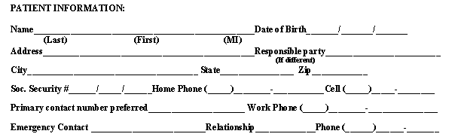

How do you know about us? Family/Friend Newspaper Website

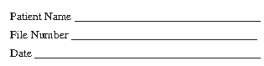
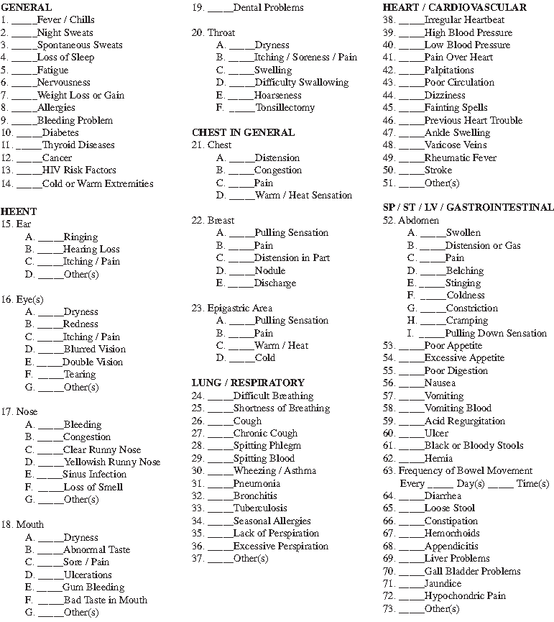
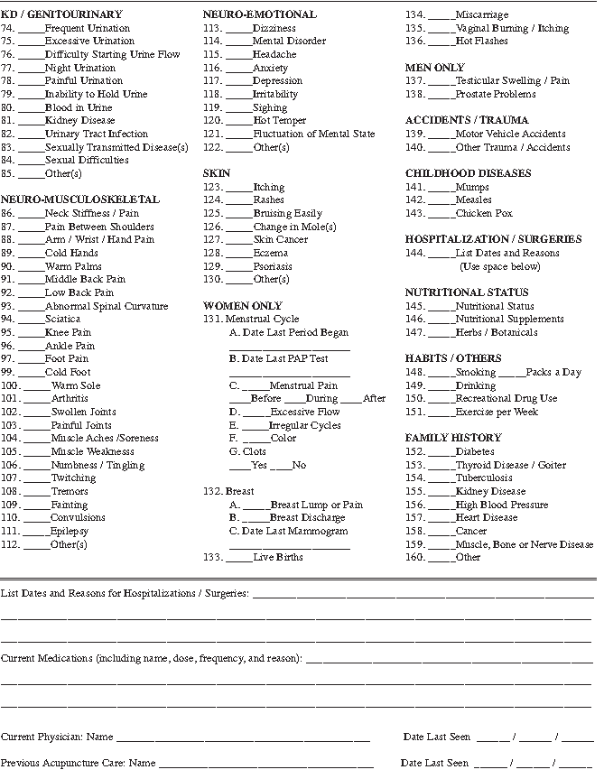

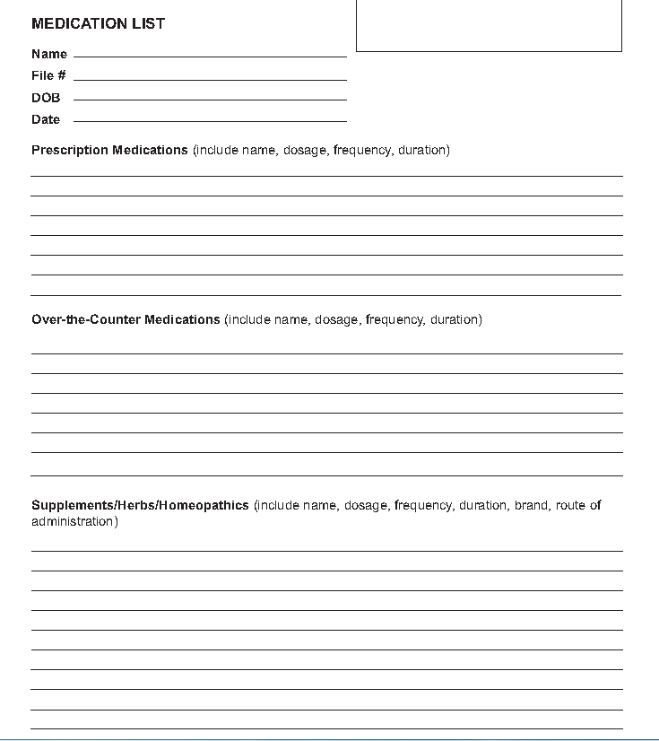
Allergies

